## horizontal line

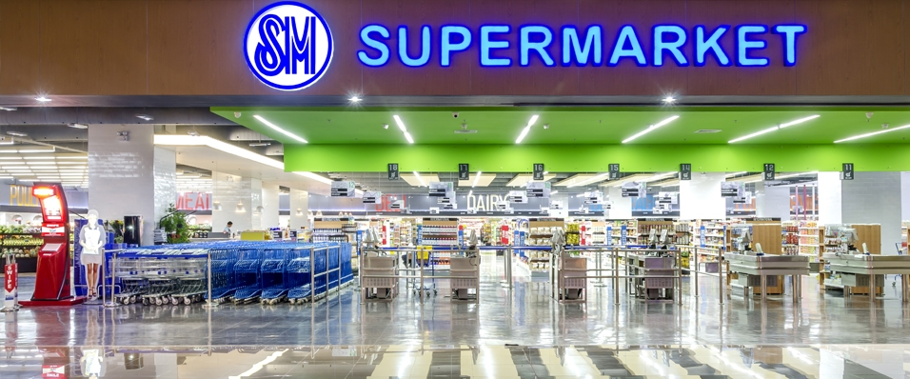

Supermarket Billing System

Project made By :-

Patel Kiran Amrutlal

Kalwal Salman

# Overview

This software project is a traditional supermarket billing system. This system is built for fast data processing and bill generation for supermarket customers. The system consists of an MS-SQL Database and effective front end designed in C#. The database is a collection of product name, price and other product specific data. A product when billed is searched from the database and its price is added to the bill based upon the product quantity. The supermarket billing system is built to help supermarkets calculate and display bills and serve the customer in a faster and efficient manner. This software project consists of an effective and easy GUI to help in easy bill calculation and providing an efficient customer service.

**Goals**

* Reduces much of human efforts in calculating bill especially for huge products.
* It provides accuracy and faultless in billing calculations.
* Easy and Attractive GUI to manage.
* Fast Processing.
* Security of details and credentials added in the system.
* Necessary validations implemented in the system to avoid invalid details to be added in the system.

**Advantages**

* It offers offline capabilities.
* The application if implemented is cheaper for long term perspective.
* The application does not require third party support for backups.

**Disadvantages**

* It relies on the computer speed.
* Multiple users cannot access the application at the same time.

**Requirement Specifications**

|  |  |
| --- | --- |
| Name of Component | Specification |
| Operating System | Windows 7 and Above. |
| Language Used | C# & SQL. |
| Database | MS-SQL Server. |
| Development Platform | Visual Studio 2015  MS-SQL Server 2014 Enterprise |
| Processor | 2.0 Gigahertz with Dual Core or Above. |
| Printer | Optional. |

**Applications**

The project can be implemented in as follows :-

* Shops.
* Supermarkets / Malls.